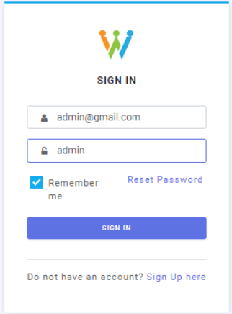

Login/SignUp

**Dashboard**

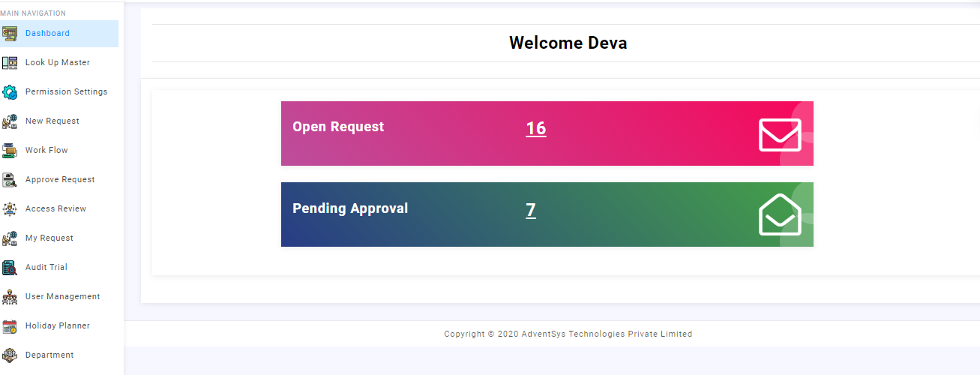

Dashboard gives information about open request,pending request and many details related to request

**LookUp Master**

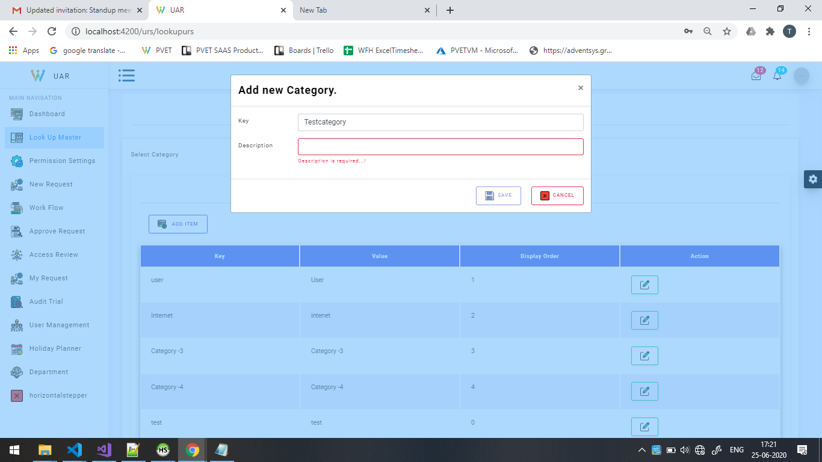

Add Category

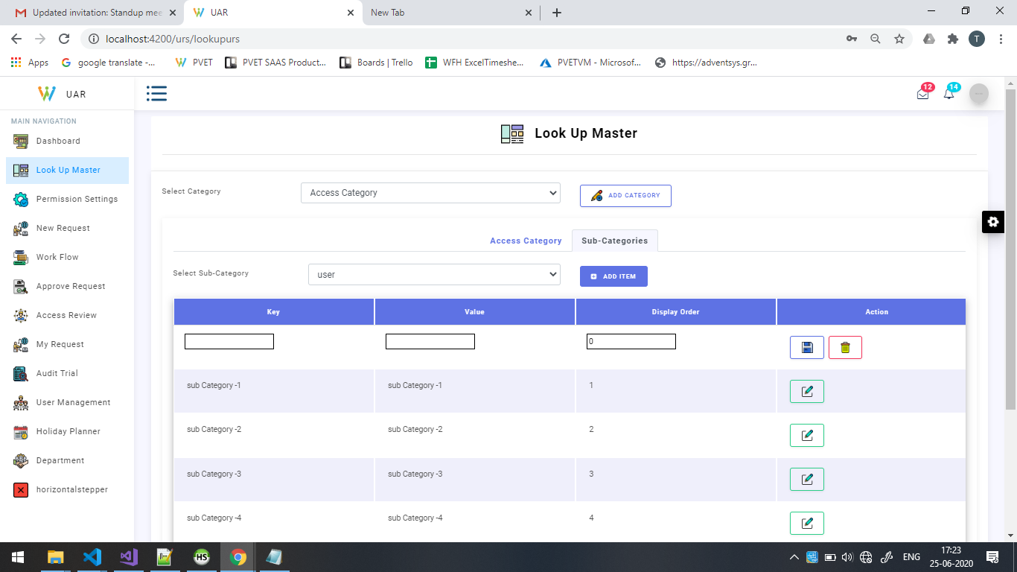

Add sub Category for the selected Category

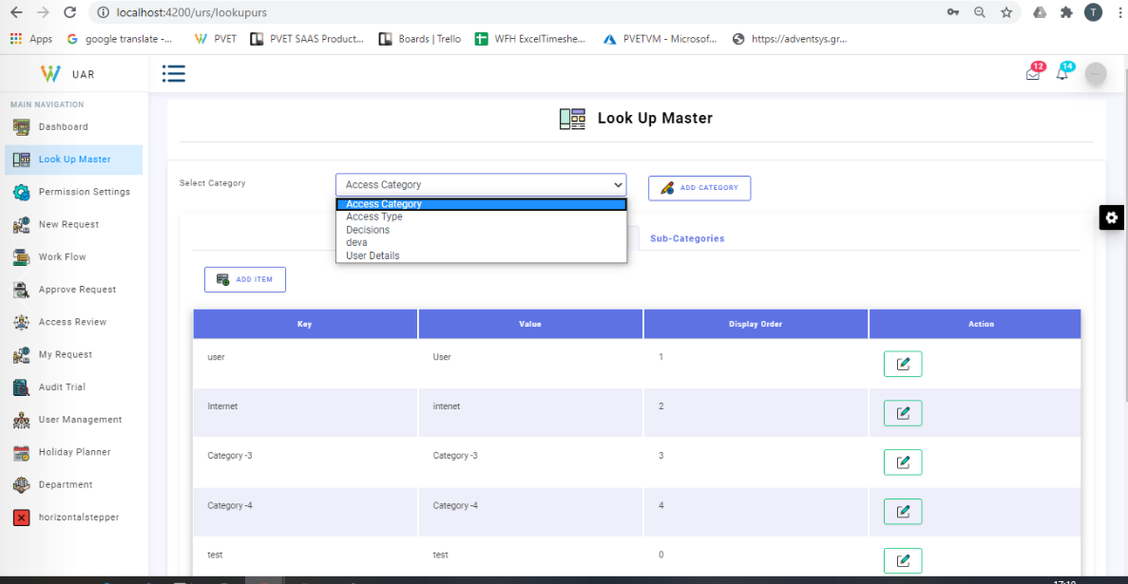

Look up master to define the Category with its Subcategories

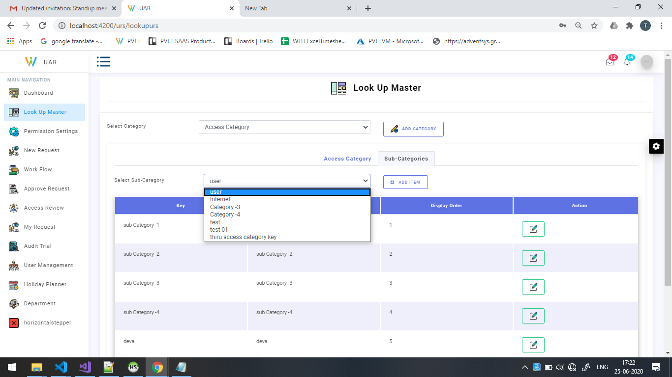

Select the category and its sub category



To add the items for the combination of categories and subcategories

**Permission settings**

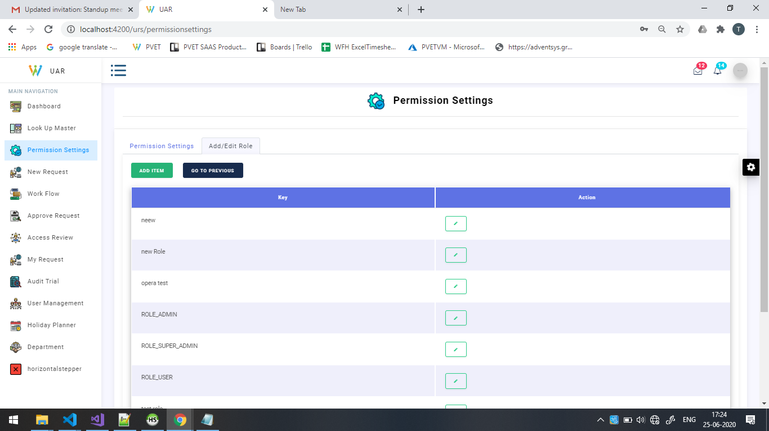

Add Role in Permission setting

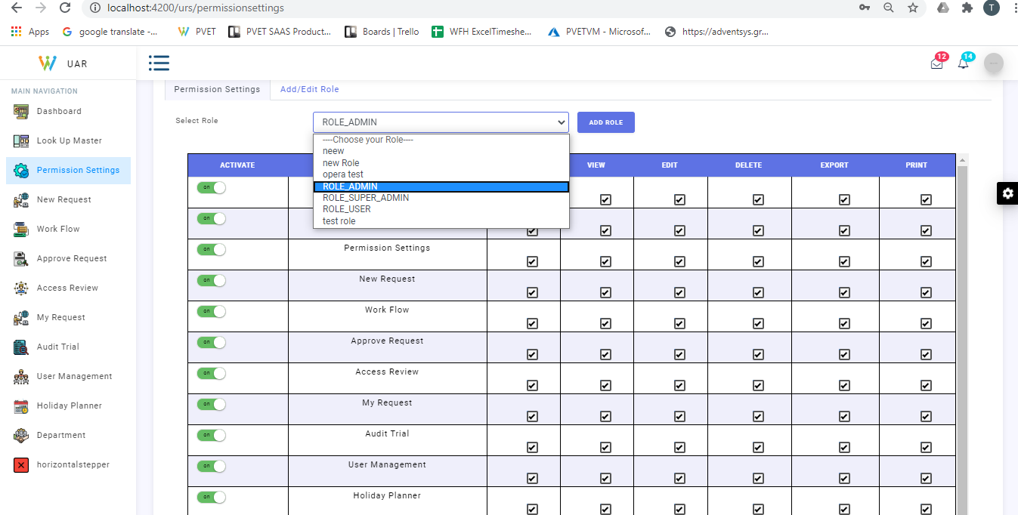 Select the required role

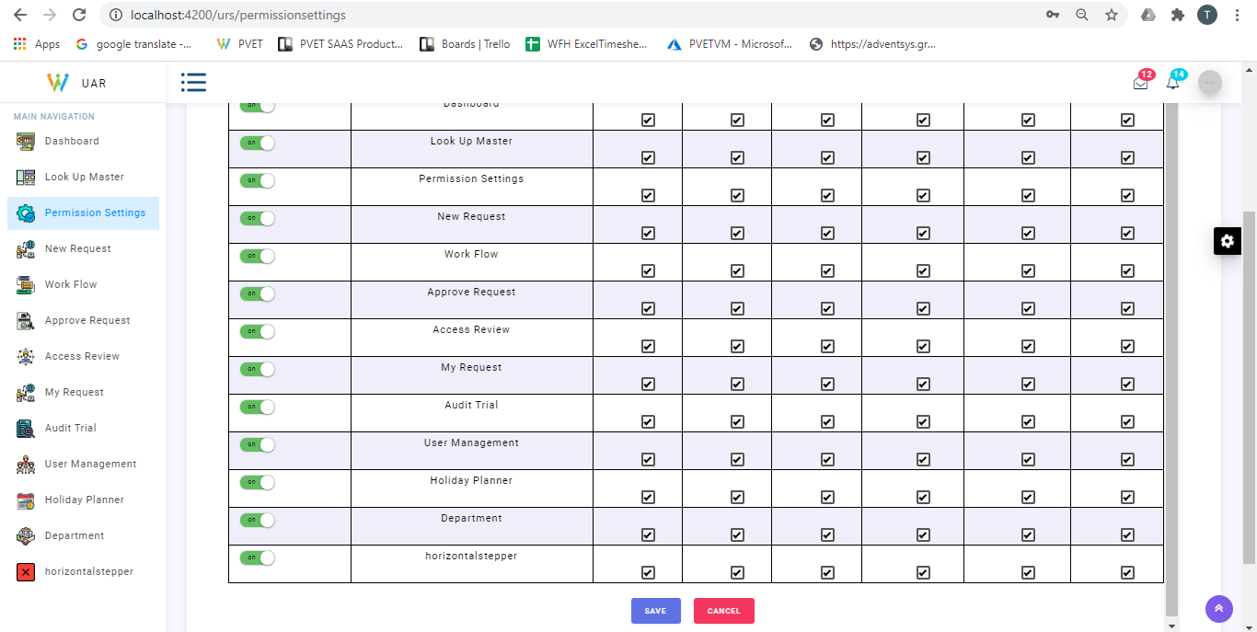

Permission Setting for module level and operation level

Eg With module wise permission setting

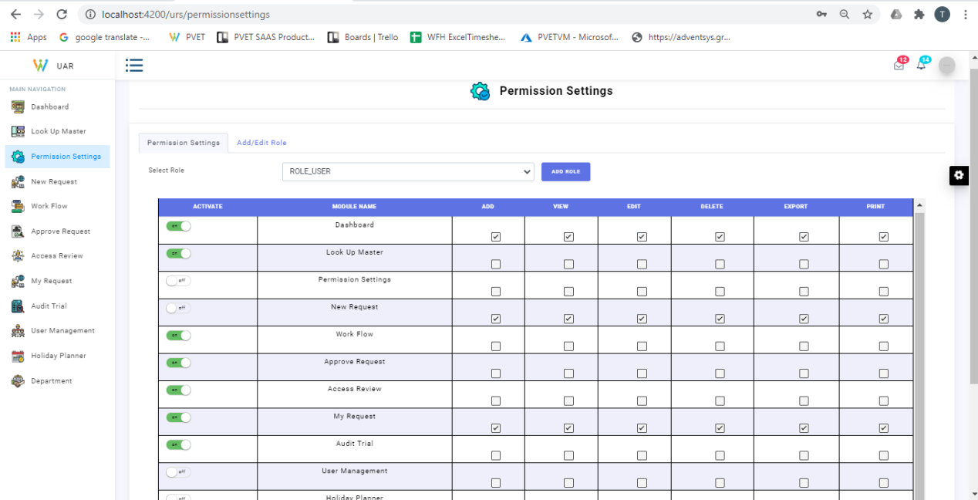

Shows that permission setting ,user management,holiday planner ,new request is disabled for role user

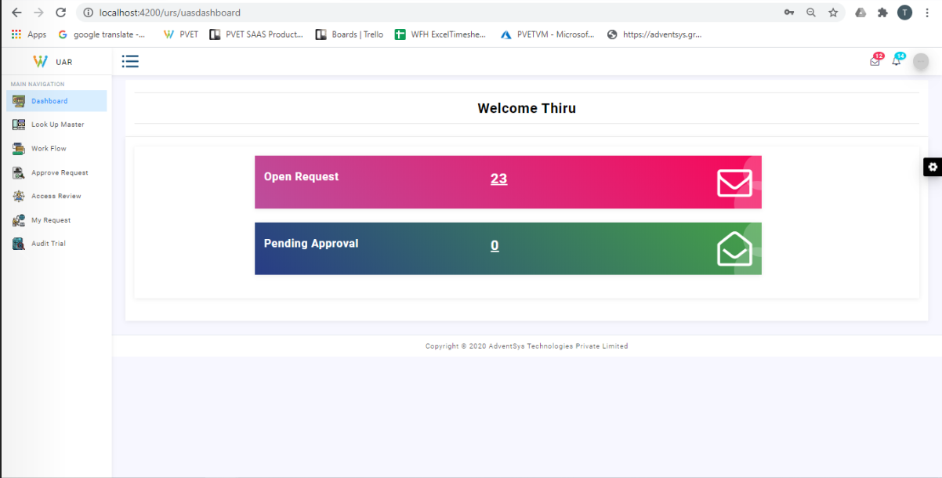

Can see that modules are not displayed for the USER ROLE

**User Management**

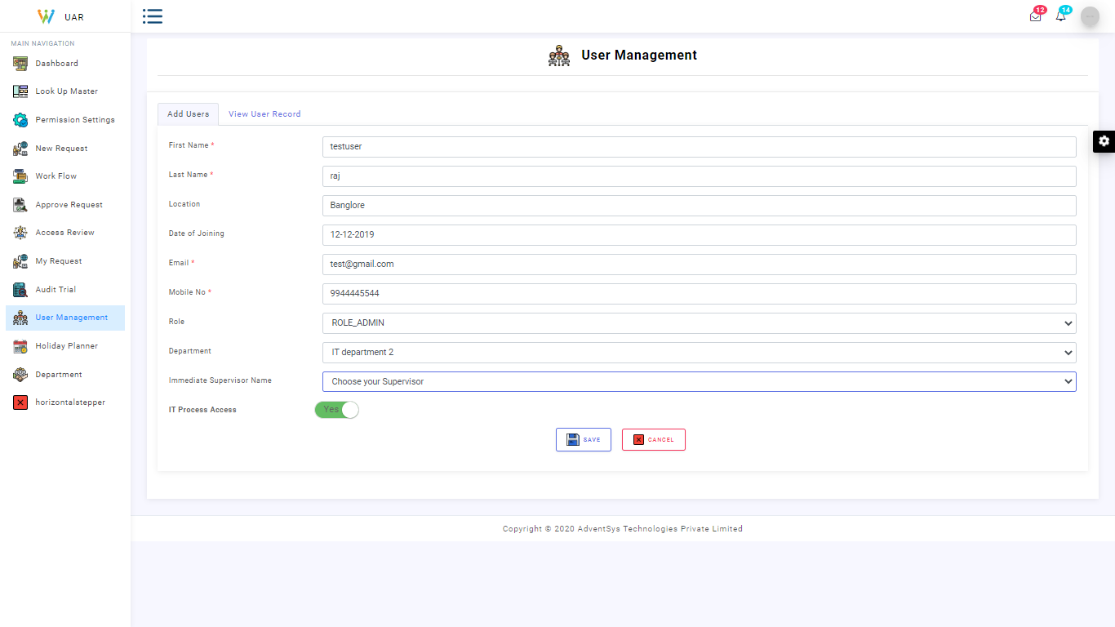

Creation of user with Basic info and assigning the role,supervisor to user and involves all the basic crud operation like edit,delete operations

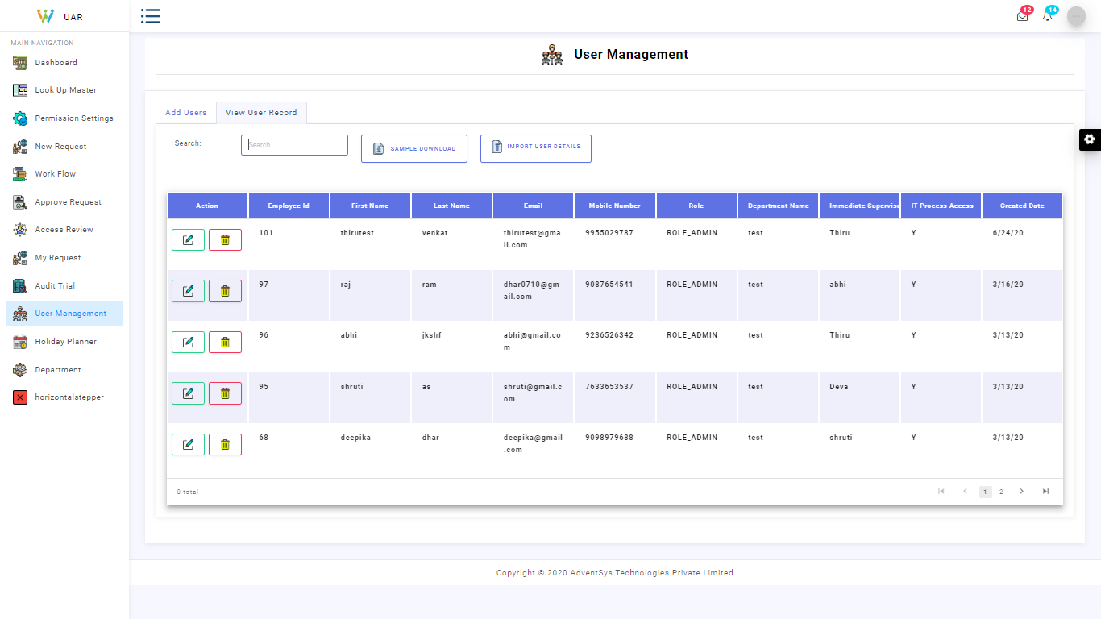

View of User Management and we can perform bulk import of users and export of user details

**Department Master**

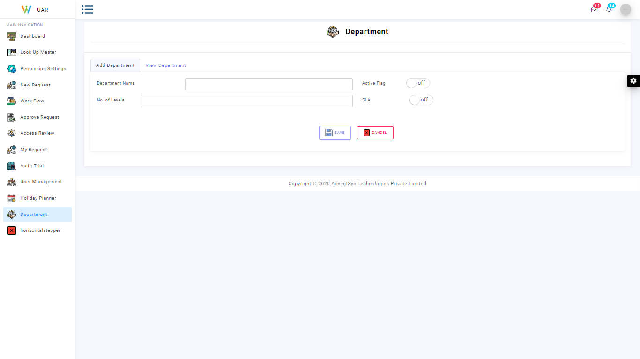

Creation of Department with SLA DAYS,Active flag

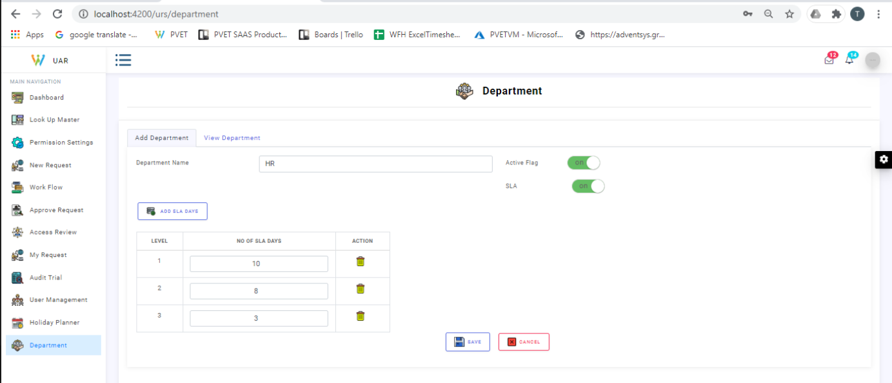

Add the Level wise SLA days for the department

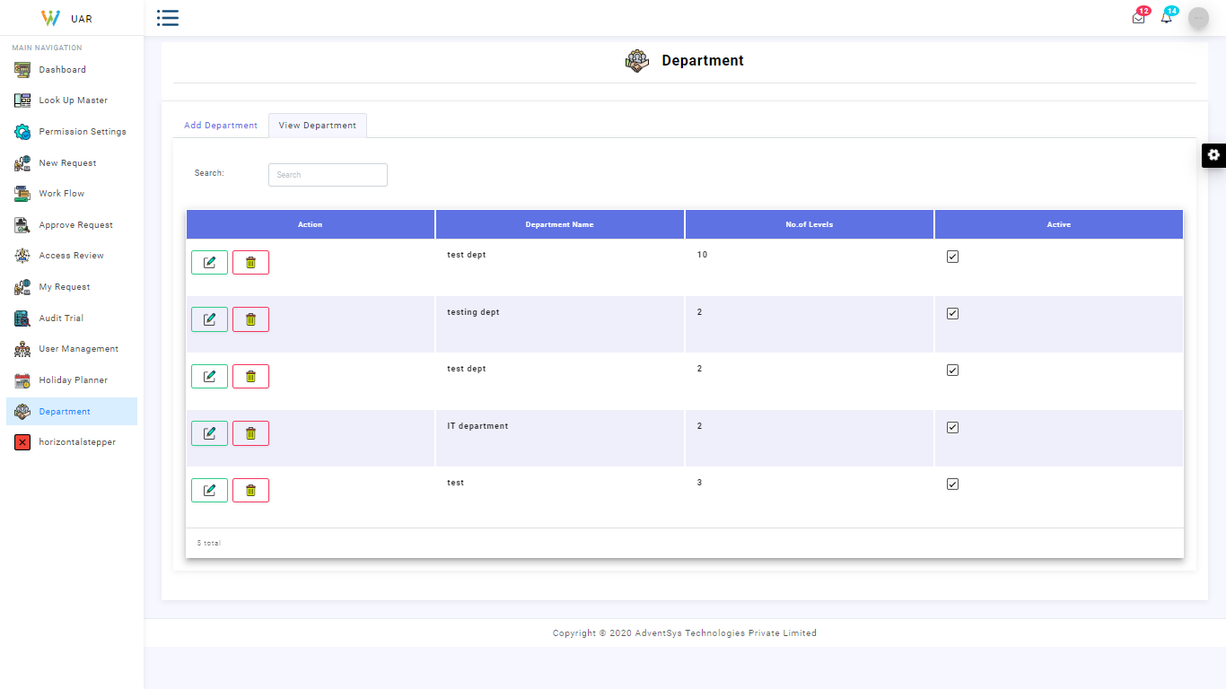

Department View and Can perform crud operations

**Audit Trail**

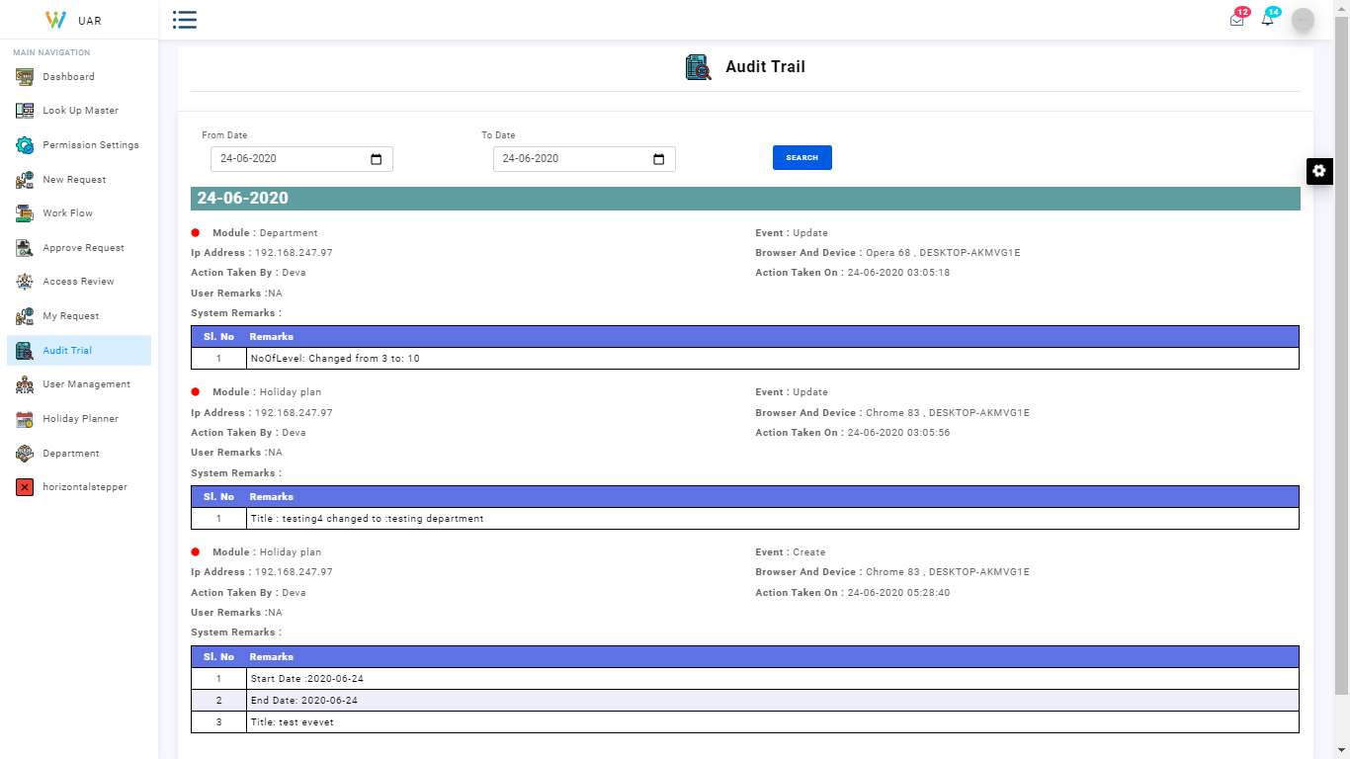

Audit Trail with all the change logs and comparison for master screens between date range

**Holiday Planner**

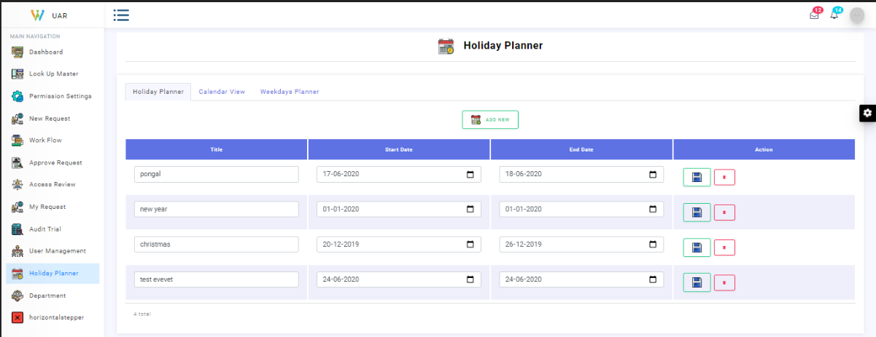

Holiday planner give required dates as holiday and mention the purpose

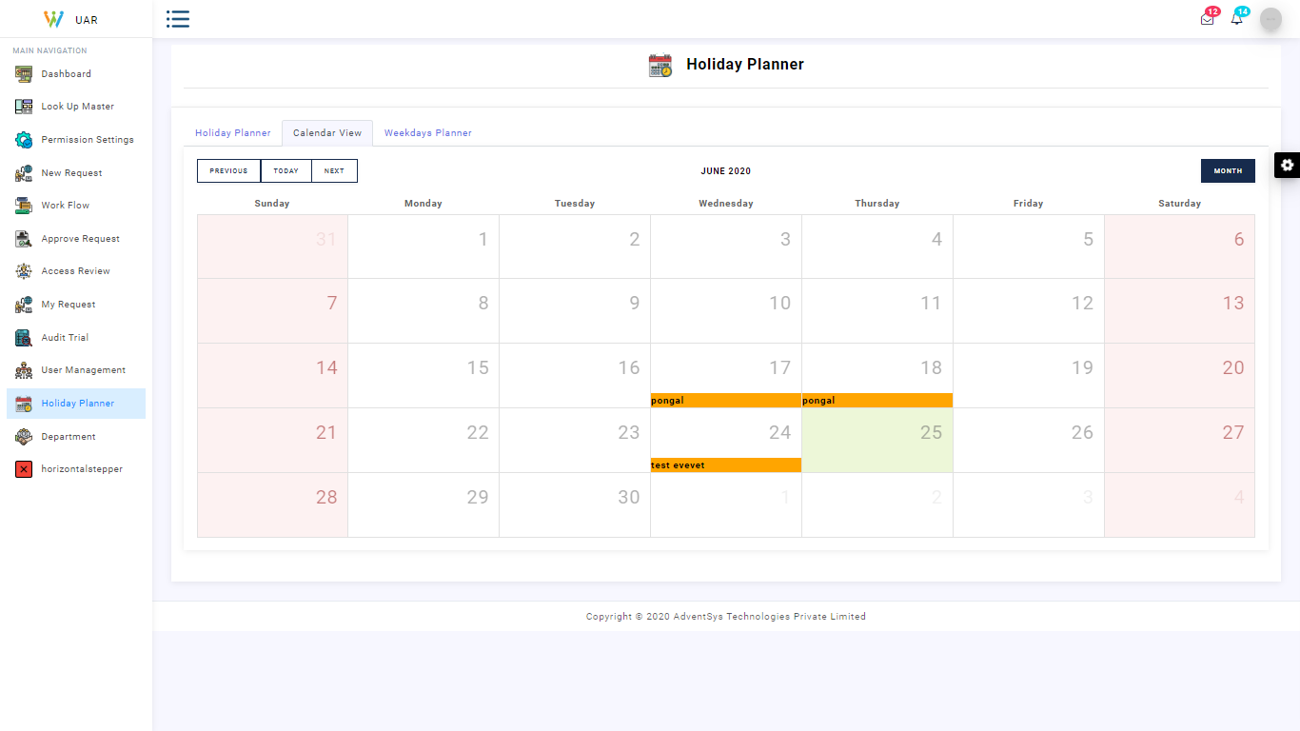

Calendar view which reflects the reason for holiday

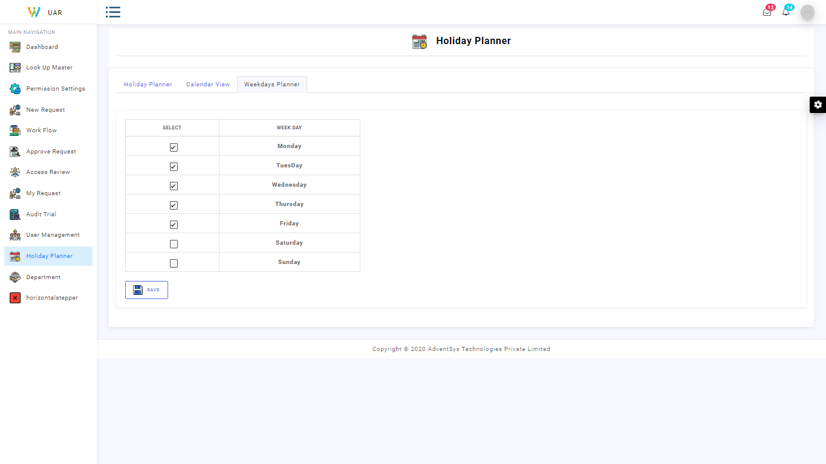

Weekday planner

Details given in the holiday planner will be further considered for SLA days calculation

**Create Request**

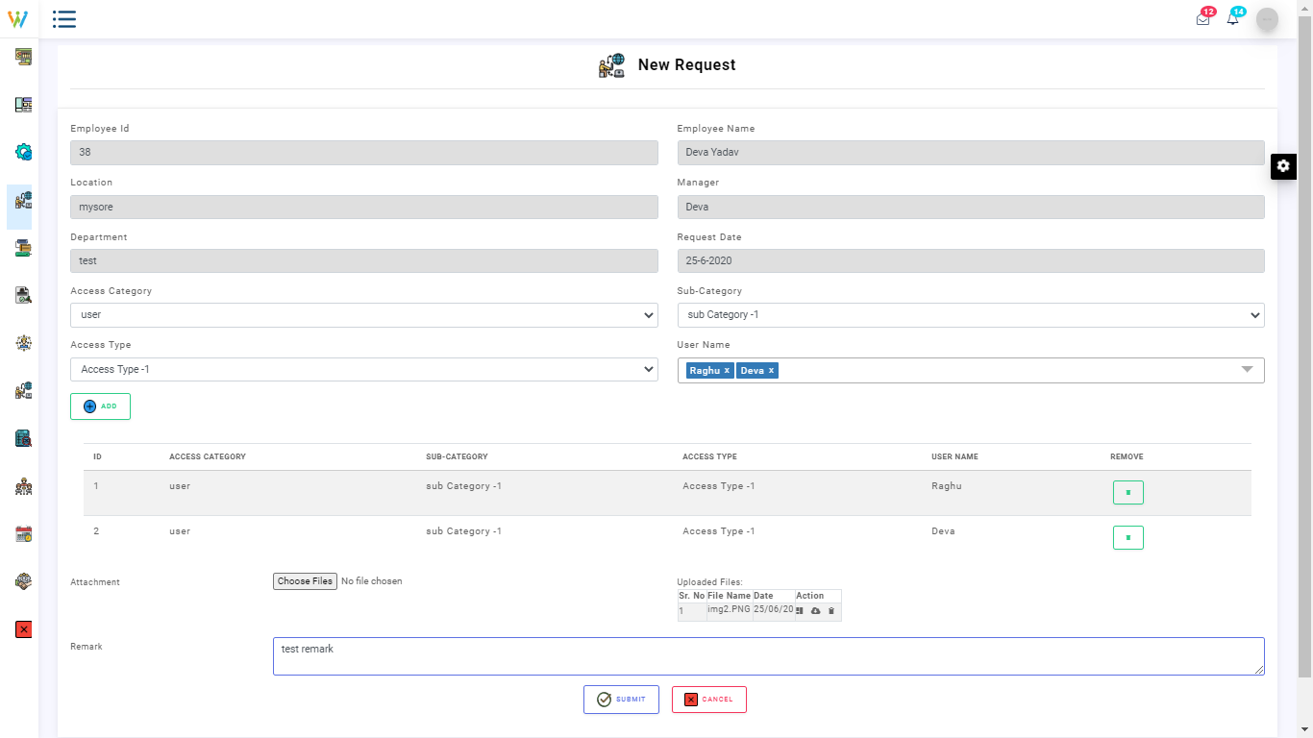

Creating a new request with selection and combination of the categories and subcategories we can perform /attach proof or provide relevant documents for the process of request

**My Request**

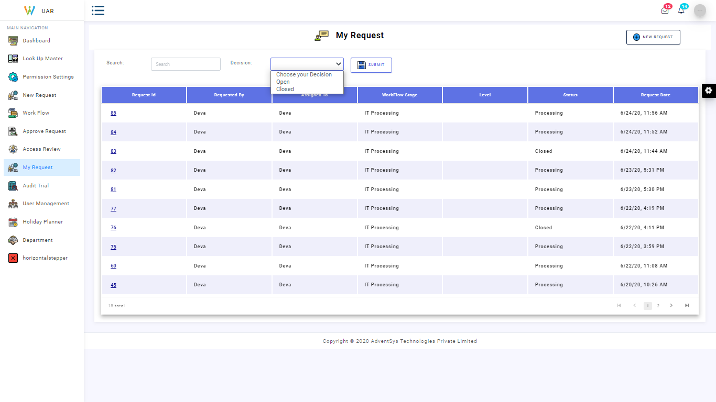

Status of the request we had asked .

**WorkFlow creation**

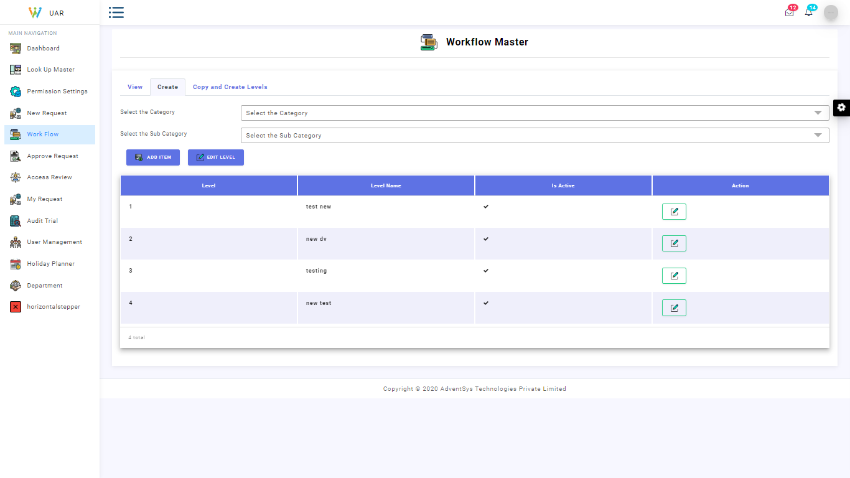

Create a Workflow master with desired Combination of Category and Subcategory

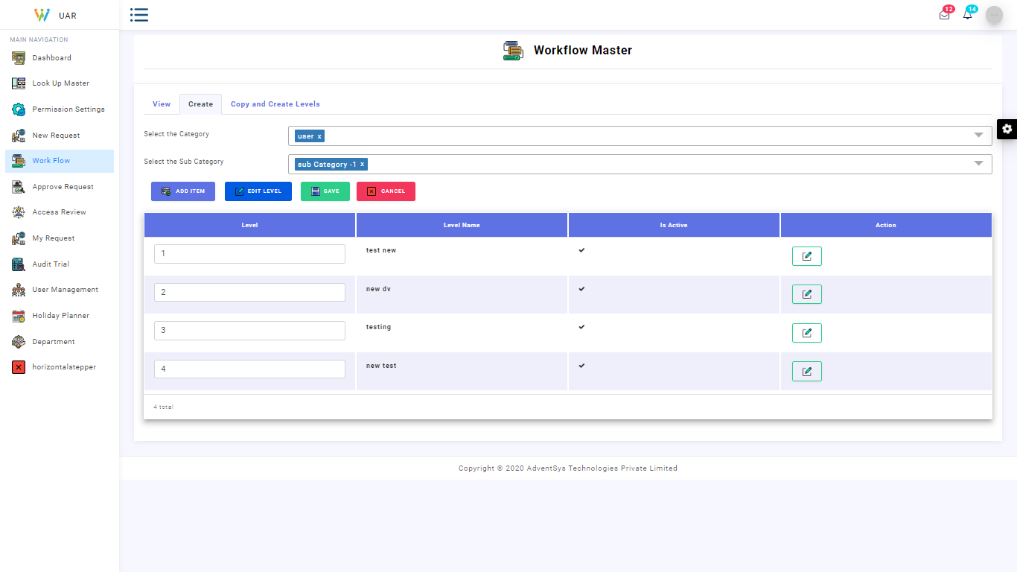

Edit operation to modify the order of level number/levels

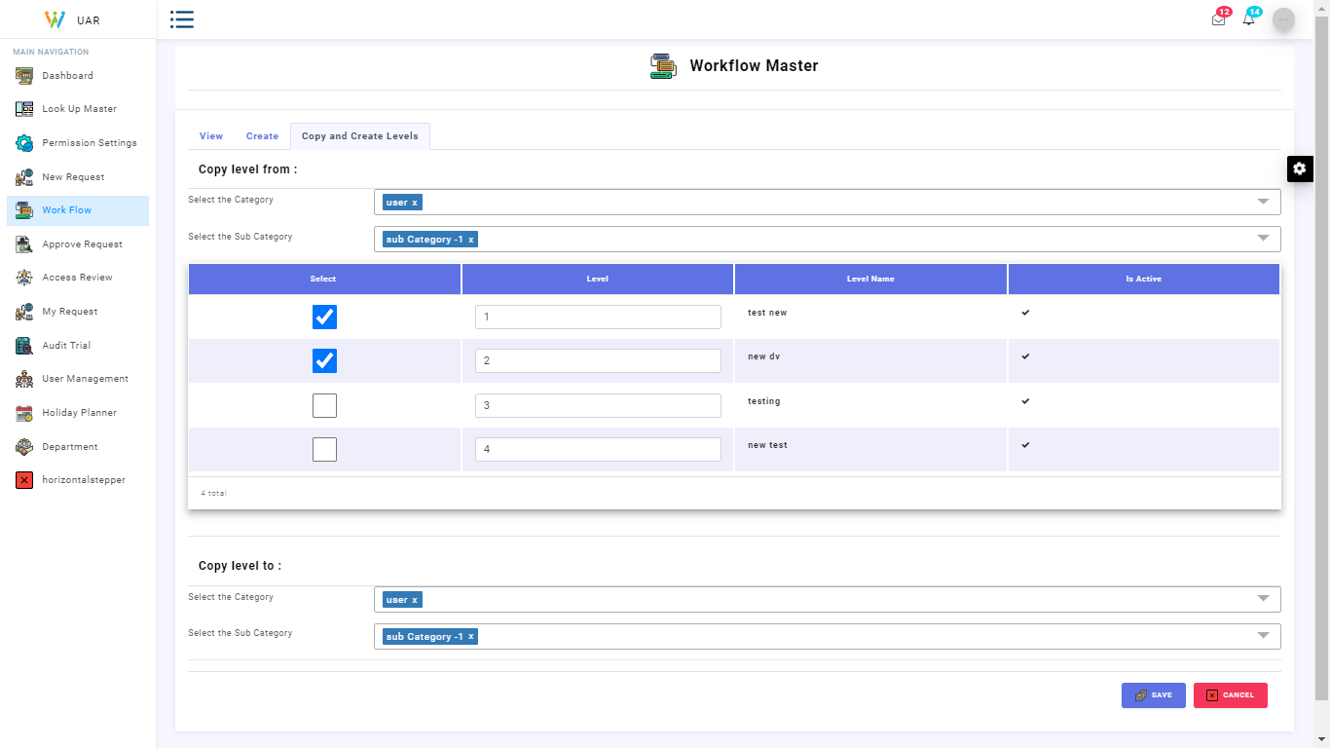

Copy the workflow levels to any other combinations of categories

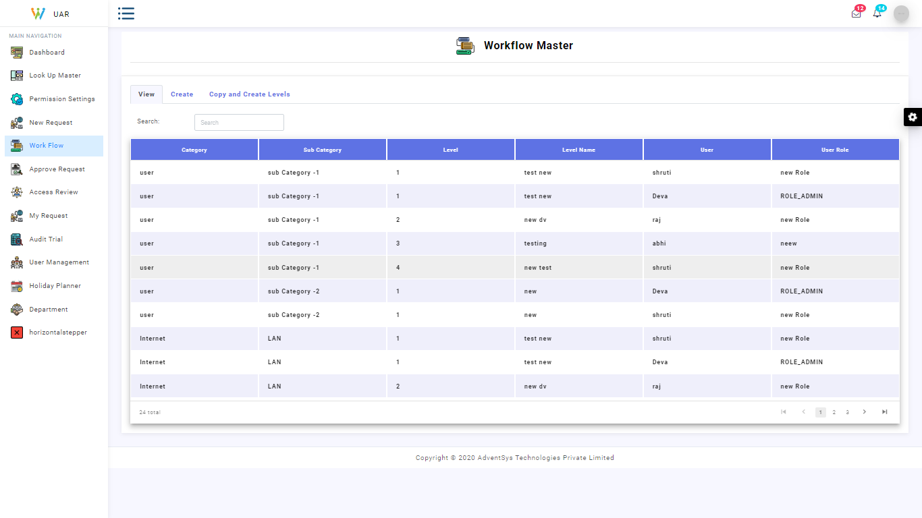

Workflow Master view

**Approve Request**

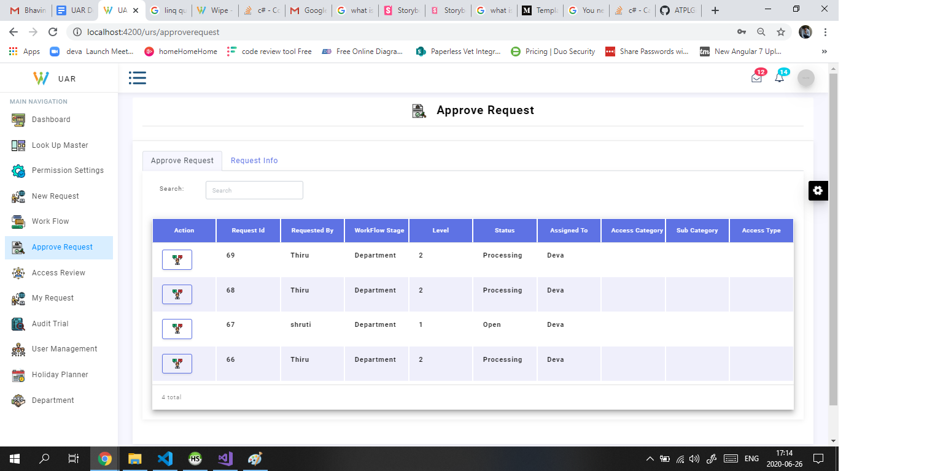

Approve request with its status

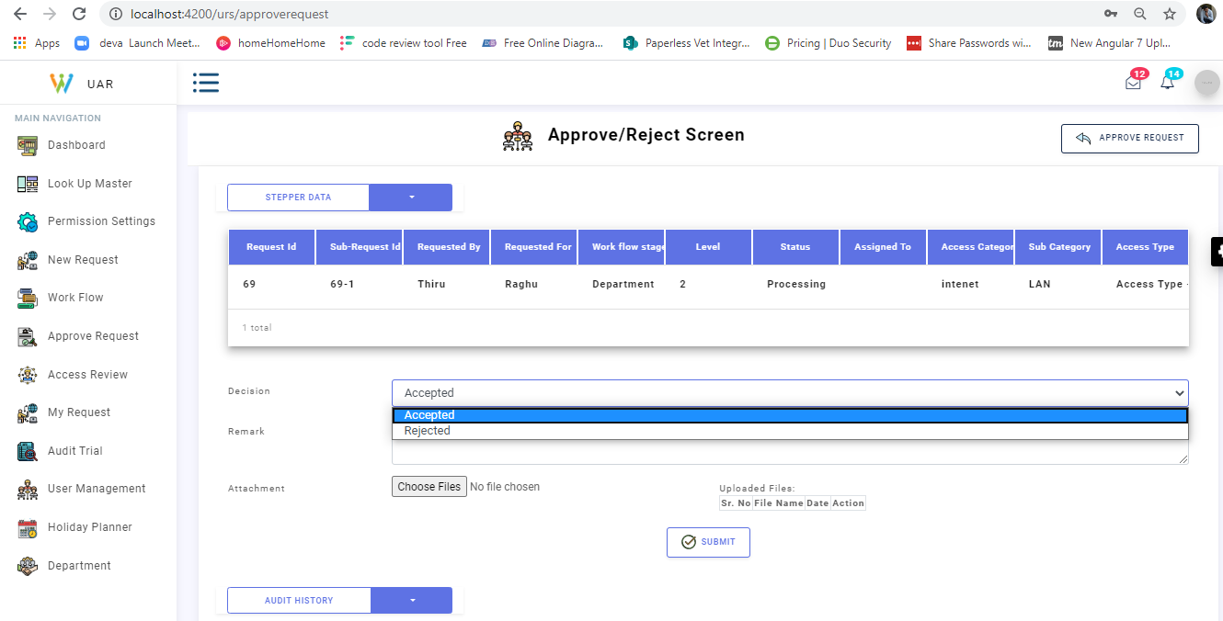

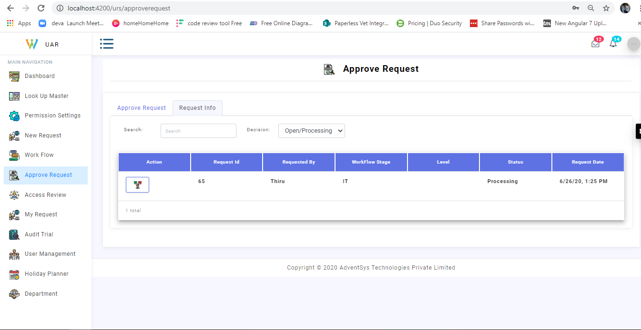

Request info view based on the Decision like open,close etc

**Approve/Reject Request View**

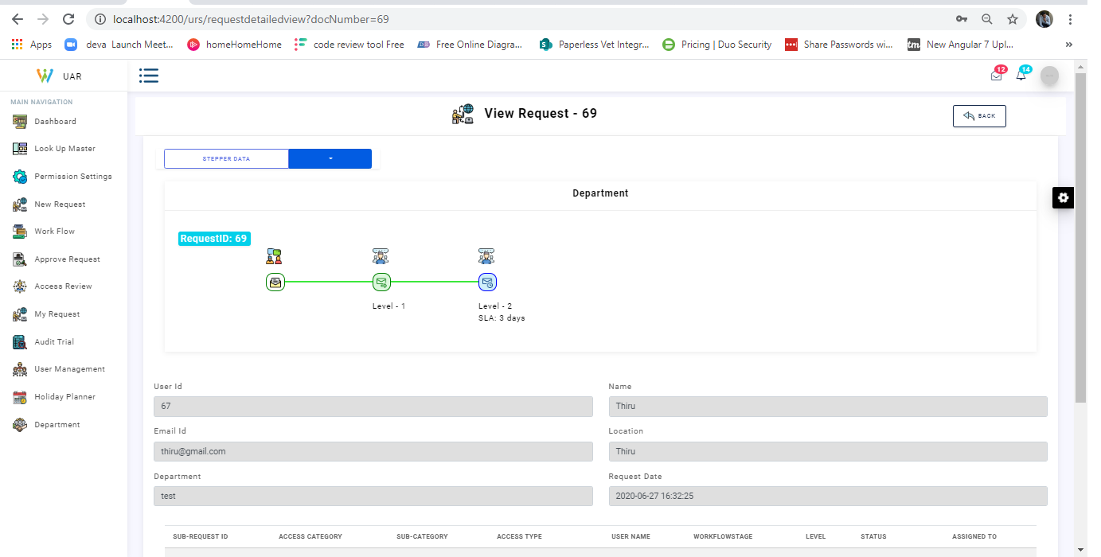

View request with the current stage

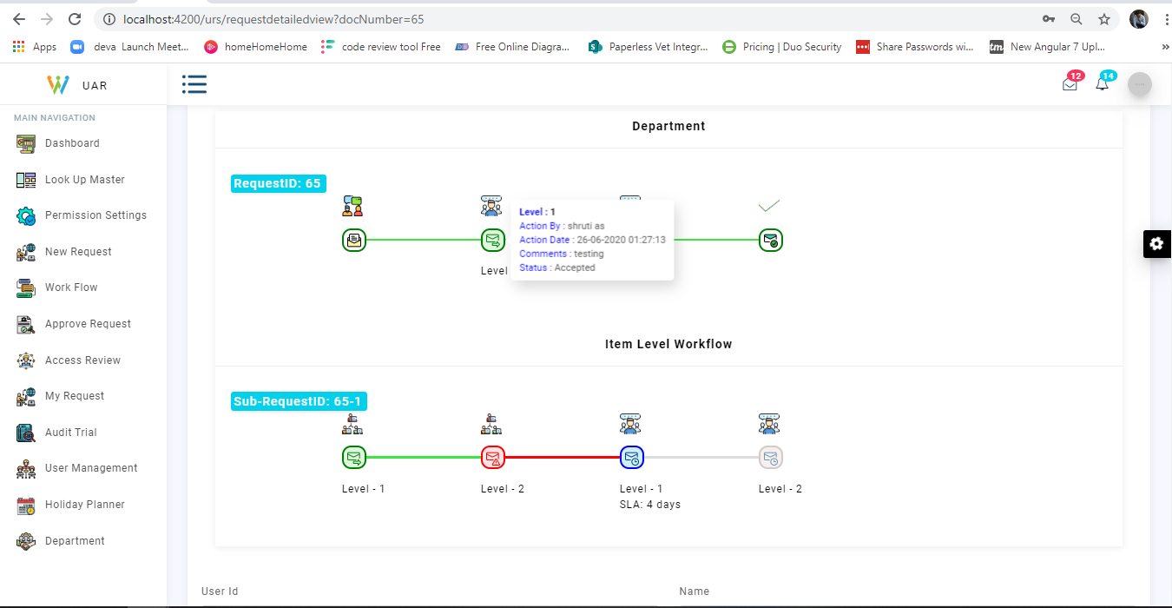

Request has been approved in level by level and gives the information regarding each level Request

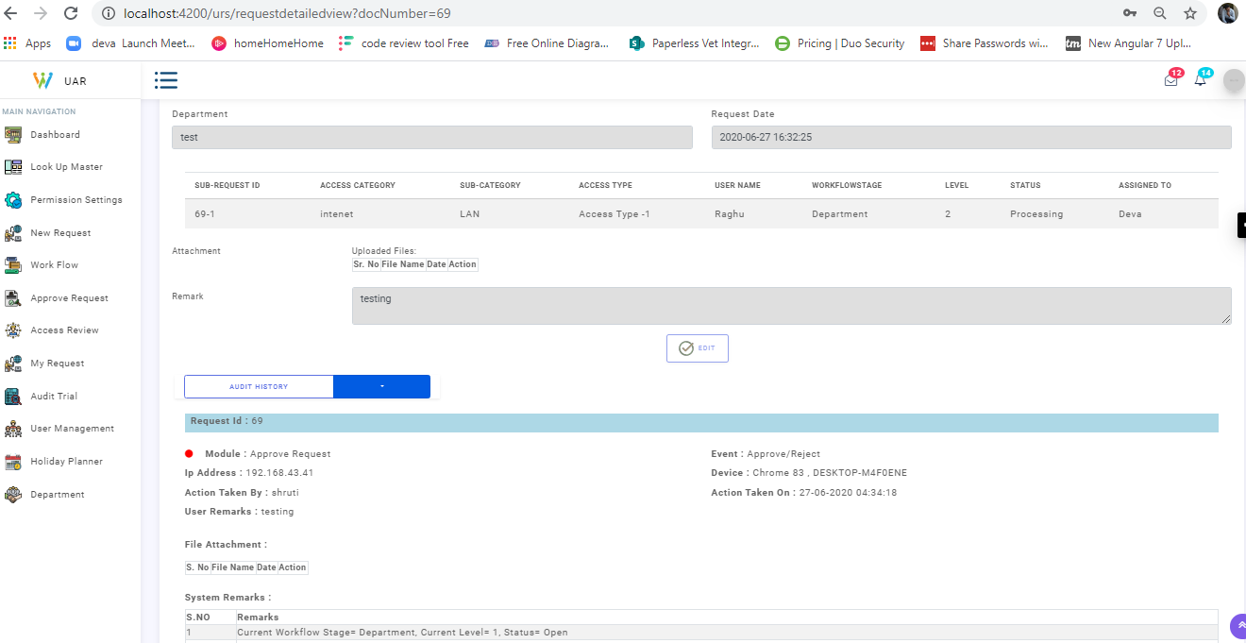

Request wise audit trail with complete flow and with current status